BIOMETHAVERSE Technical Workshop
Uppsala (Sweden)
AGENDA
14.06.23

Co-funded by the European Union. Views and opinions expressed are however those of the author(s) only and do not necessarily reflect those of the European Union or CINEA. Neither the European Union nor the granting authority can be held responsible for them.

Wednesday, 14 June 2023 – Technical Workshop
At Green Innovation Park at Ulls väg 29c, 756 51 Uppsala
Time | Topic | Moderator
15.10 - 15.30 | Coffee break
15.30 - 15.40 | National policies and site demo (Greece) | Dimitris Kourkoumpas (CERTH)
15.40 - 15.50 | National policies and site demo (Italy) | Maria Rosaria Scoppettuolo (CAP)
15.50 - 16.00 | National policies and site demo (Sweden) | Emelie Ljung, Johan Andersson (RISE)
16.00 - 16.10 | National policies and site demo (Ukraine) | Oleksandr Dombrovskiy (MHP)
16.10 - 16.20 | National policies and site demo (France) | Gaspard Bouteau (ENGIE)
16.20 - 16.50 | Q&A (Discussion on policy barriers and drivers to scale up biomethane production)
16.50 - 17.00 | Conclusions | Stefano Proietti (ISINNOVA)

PRACTICAL INFORMATION

Uppsala - how to find your way here

Bus and trains to Uppsala
It is easy to travel to Uppsala. There are both buses and trains from Arlanda airport. From Stockholm central to Uppsala, there are both commute- and regional train.

Note! If you come to other Stockholm, Sweden airports as Bromma or Skavsta airport. Take the bus or commute alternatives to Stockholm central. From there travel to Uppsala by commute- or regional train.

From Arlanda airport to Uppsala
There are commuter trains and regional trains that you can take from Arlanda to Uppsala. There is also a bus, number 801 that departs from Arlanda to Uppsala.
Links for more information:

- UL
- SJ
- Mälartåg

Taxi

If you prefer you can also take a taxi to Uppsala. Here are some examples on taxi companies:
- Uppsala Taxi
- Taxikurir

How to get to Green Innovation Park – Uppsala
RISE in Uppsala is located at Campus Ultuna, six km south from the city center.
One of our neighbors is Green Innovation Park, where we will be during the consortium meeting and technical Workshop in Uppsala 14th June.
NOTE! We will look for a solution with coordinated transportation if you stay at hotel Fyrislund!
Visiting address
Green Innovation Park
Ulls väg 29C
756 51 Uppsala
Link to map

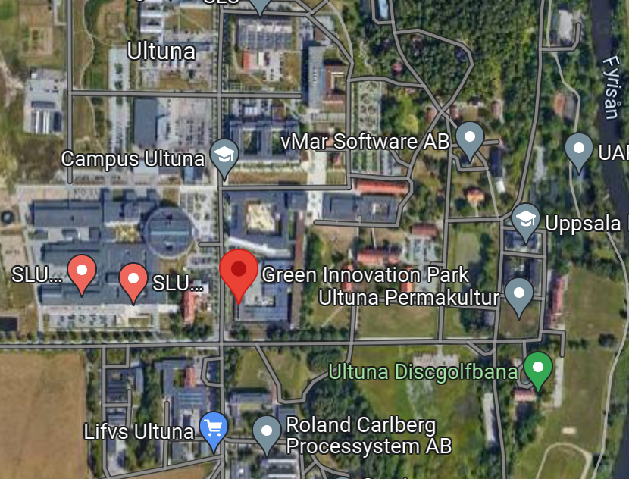

Coordinates
WGS84 decimal (lat, lon)
59.822214, 17.467575

From Uppsala central station to Campus Ultuna
You can take the city bus number 4 or regional buses 100 or 101 to the bus station called Campus Ultuna. From there it is just a short walk at campus.

- UL
Taxi
If you prefer you can also take a taxi to Campus Ultuna. Here are some examples on taxi companies:
- Uppsala Taxi
- Taxikurir

Contact information
Further questions? Don’t hesitate to contact Emelie Ljung or Lina Heldmark and we will help you.

Name: Lina Katarina Heldmark Emelie Ljung
Email: lina.katarina.heldmark@ri.se emelie.ljung@ri.se
Phone: +46 10 722 33 19 +46 10 516 69 85
Mobile: +46 73-092 68 91 +46 73 610 29 06

